Health Providers in Northwest Suburbs
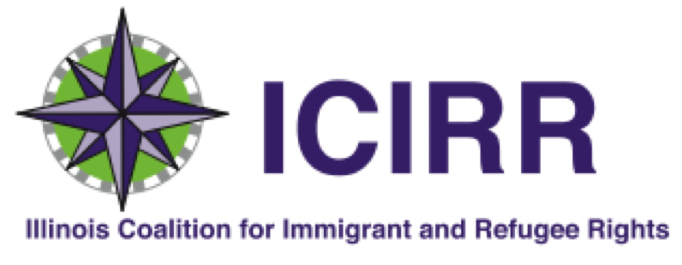

HOSPITALS
Streamwood Healthcare System, Behavioral Streamwood Hospital
1400 East Irving Park Road Streamwood, IL 60107-3203,
630-837-9000, http://streamwoodhospital.com/
- Financial assistance: Work with undocumented, uninsured, underinsured on a case-by-case basis. Assessment & Referral Intake Clinicians are available to provide assistance at (800) 272-7790 Ext. 5573
- An uninsured patient who meets certain income requirements may qualify for an uninsured discount.
- Services: Provides free written and linguistic translation services, also offers accommodations for disability
- Contact: Brynn Obrien, Civil Rights Coordinator, 630-837-9000 ext 4296, Fax: 630-540-4297, Brynn.Obrien@uhsinc.com

Alexian Brothers Medical Group
http://www.alexianbrothershealth.org/doctor
800 Biesterfield Road, Elk Grove Village, IL 60007
Phone: 847-437-5500
http://www.alexianbrothershealth.org/abmc

- 1555 Barrington Road, Hoffman Estates, IL 60160
Phone: 847-834-2000

- Behavioral Health Hospital
1650 Moon Lake Boulevard
Hoffman Estates, IL 60169
Phone: 800-432-5005

- Rehabilitation Hospital
935 Beisner Road
Elk Grove Village, IL 60007
Phone: 847-640-5600

- Medical Center 800 Biesterfield Road, Elk Grove Village, IL, 60007
847-437-5500

361 West Golf Road, Schaumburg, IL 60195
847-952-7447

- Rehabilitation Hospital 935 Beisner Road, Elk Grove Village, IL 60007
847-640-5600

- St. Alexius Medical Center 1555 Barrington Road , Hoffman Estates, IL 60169
847-843-2000
- Behavioral Health Hospital
1650 Moon Lake Boulevard, Hoffman Estates, IL 60169
800-432-5005

- Women & Children's Hospital
1555 Barrington Road, Hoffman Estates, IL 60169
847-843-2000

- Financial Assistance: Help is available by contacting 866-690-3370, emailing ABHSAlexianAssistance@AMITAhealth.org or in person at any of our facilities. If your income is less than or equal to 250% of the Federal Poverty Level, you will receive a 100% charity care write-off on the portion of the charges for which you are responsible.
- How to apply: Complete a written application and provide supporting documentation (copies of tax return, W2’s, and pay stub).
- If your income is above 250% of the Federal Poverty Level but does not exceed 400% of the Federal Poverty Level, you may receive discounted rates on a sliding scale.
- Assistance for uninsured patients, following Illinois HUPDA:
  - 100% discount from 0 to 250% of FPL
  - Current HUPDA discount from 251% - 600%
  - AGB discount above 600%
- Assistance for insured patients, fallowing Illinois HUPDA:
  - 100% discount from 0 to 250% of FPL
  - Current HUPDA discount from 251% - 400%

Northwestern Medicine
https://www.nm.org/
- Candace Health Physical Therapy, South Elgin
552 Randall Rd, South Elgin, IL 60177
(630) 315-6880
- Convenient Care
820 Route 59, Bartlett, IL 60103, (630) 213-9600
- Rehabilitation Services
820 Route 59, suite 320, Bartlett, IL 60103
- Financial Assistance: Will not turn away any patient based on inability to pay. Must fill out application to be considered for free or reduced fee service, for both uninsured and insured patients. Application is available in English and Spanish.
- Services: Language translation services are offered, contact the Patient Relations Department at (312) 926-3112

Advocate Sherman Hospital & Health
- http://www.advocatehealth.com/sherman
- 1425 N Randall Road & 750 Fletcher Drive
Elgin, IL 60123
Phone: (847)742-9800
- Medicaid: yes
- Financial assistance: Offers counselor, discounts to both uninsured & insured patients
http://www.advocatehealth.com/financialassistance (Application is available in English, Spanish, or Polish). Bring driver's license or State ID & any authorization forms & a physician’s order if you have one, and sign a release of information form. Up to 100% discount available, according to individual need. Financial counselor is assigned to patients upon completing the Financial Assistance Application. They will assist patients with applying for Illinois Medicaid, All Kids, FamilyCare, or Marketplace; and will determine if they qualify for free medical care, Affordable Care Act enrollment, Social Security Disability Benefits, Supplemental Security Insurance (SSI) benefits, and Emergency Medical Coverage (EMC).

Presence Saint Joseph Hospital
http://www.presencehealth.org/presence-saint-joseph-hospital-elgin
77 Airlite Street
Elgin, IL 60123
Phone: (877)737-4636
  - Medicaid: Accepts Medicaid and Medicare
  - Financial assistance: Uninsured self-paying patients receive an automatic 40% discount, no application is necessary. Can apply for Financial Assistance Program to receive discount, up to free care, based on income and family-size [link to application below]
http://www.presencehealth.org/documents/patients-visitors/financial-assistance/FinancialAssistanceHospitalApp.pdf Form is also available in Spanish & Polish, and social security number not

CLINICS
Cook County Health and Hospital System: Vista Health Center
1585 N Rand Rd, Palatine, IL 60074
http://www.cookcountyhhs.org/health-centers/vista-health-center/
(847) 934-7969
Open: Mon Wed 10:00am-6:00pm, Tues, Thu, & Fri Sat 8:00am-4:00pm

- Financial assistance: Call 312-864-8200 to learn more about your coverage options. Their office can determine Medicaid and Medicare eligibility, and certified application counselors are available to help individuals enroll in a plan through the Illinois Health Insurance Marketplace.

- Services: by appointment only
- Contact: Victor Medina, Administrative Leader /Nurse Coordinator, (847) 934-7969
The Bridge Youth & Family Services
721 S. Quentin Road, Suite 103, Palatine, IL 60067
(847) 359-7490
After-Hours Support Line (847) 776-3720
https://bridgeyouth.org/
- Financial assistance: No one is turned away due to inability to pay for services, collects donations on behalf of improving service to those in need
- Services: Offers service in Spanish

Women’s Health First
1931 N Meacham Rd, Schaumburg, IL 60173
Womenfirst.net
(847) 808-8884

- Financial Assistance: Can contact their billing department at 847-776-4014 for English, and 847-776-4049 en Espanol. Payment is expected at time of service with cash or credit card.
- Services: all services are offered in English and in Spanish

Access Community Health Network, Martin T Russo Family Health Center
https://www.achn.net/
- 36 different local Federally Qualified Health Centers (FQHC) in Cook County and DuPage County
- 245 S. Gary Ave., suite 101, Bloomingdale, IL 60108
- Services: Pediatrics, Family Medicine, Obstetrics and Gynecology, Family Practice, Internal Medicine, Midwifery, Infectious Diseases, Behavioral Health
- Service offered in Spanish
- Financial Assistance: Requests can be made for financial assistance on a case-by-case basis

Schaumburg Immediate Medical Center
1375 E Schaumburg Rd #100,
Schaumburg, IL 60194
(847) 891-6850
- Financial assistance:
  - Options for non-insured, How to apply: Call to make appointment & bring coupon with you or say this discount ID: SICREG1:
  - Basic – visit includes clinical exam, patient history rapid test performed in office, prescription written
    - Coupon price: $99.99
    - Cash price: $110.00
- Intermediate – basic visit plus: x-ray (one body part), test performed/interpreted in office
    - Coupon price: $199.99
    - Cash price: $260
- Advanced: Intermediate visit plus one of the following procedures: Burn care, suture cuts, incision and drainage, asthma treatment, foreign object removal, intravenous therapy, eye numb/wash, splinting

Life Choices Medical Clinic
127 S Roselle Rd,
Schaumburg, IL 60193
(630) 339-3660
Financial Assistance:
- Free Clinic- Offers:
  - Basic Services: Pregnancy Tests (urine), Ultrasound - On-Site, Abortion Information, STD Testing, 24/7 Hotline, Maternal Aid, Peer Counseling
  - Long term Services: Pre-Natal and Post-Natal classes, hope Services – an ongoing maternal support program for mothers, Men's Support Program

Greater Elgin Family Care Center, Streamwood Community Health Center
135 Irving Park Rd
Streamwood, IL 60107
(630) 313-5300
http://gefcc.org/
- Financial Assistance: Offer a sliding fee discount program to all patients who are under 200% of the Federal Poverty guidelines based on reported income and family size.
  - All patients presenting who are below 100% of the Federal Poverty guidelines based on reported income and family size will receive a full discount.
  - Nominal fees may be collected from individual or families with an annual income at or below 100% of the Poverty Level.
- Services: Staff is bilingual in Spanish
- Contact: Kimberley Slagle, Billing Coordinator, at (847) 608-6001 or kslagle@gefcc.org to apply.
Greater Elgin Family Care Center, graphic showing sliding discount fee for service: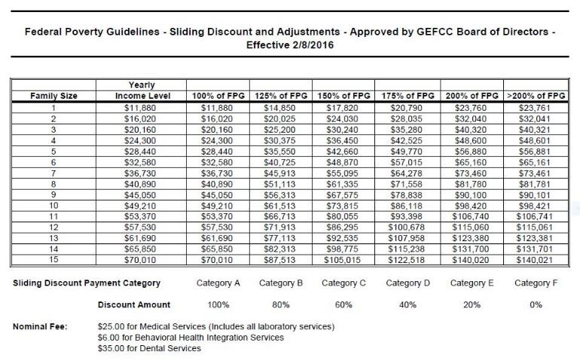
Palatine Pediatrics (includes Women &Maternal care)
600 N. North Ct., Palatine, IL 60067
(847) 359-5000
- Financial Assistance: Application, http://www.palatinepediatrics.com/policies
Additional documents required: One document proving residency in Cook County.
- May be asked for (depending on circumstance): Birth record, Written verification from employer, Military record, Child support payments and alimony records, School or day care record, Unemployed benefits statement, Court-ordered guardianship/conservatorship, SSI letters and RSDI letters, Immigration and naturalization records, Statement of dividends, interest and royalties, Paycheck stubs, Education/training stipends, Tax return, Pension and annuity statements, Divorce decree, Veteran’s Administration Benefits, Marriage license, certificate or declaration of informal marriage form, Worker’s Compensation letter.
- At least 1 photo identification
Patients may qualify for financial assistance if:
- Do not have to be a current or former patient to apply
- Insured or uninsured
- Your income is below 600% of the Federal Poverty Level.
- You are resident of Cook County.
- Financial assistance is available on sliding scale
- Assistance can apply to clinic visits, laboratory services, hospital stays, prescriptions, and urgent & emergency care.

